FWC IITH INTERNSHIP
DIGITAL – DESIGN
ASSEMBLY:
- ATmega328P assembly programming language.
- .include “m328Pdef.inc” [library]
Question:
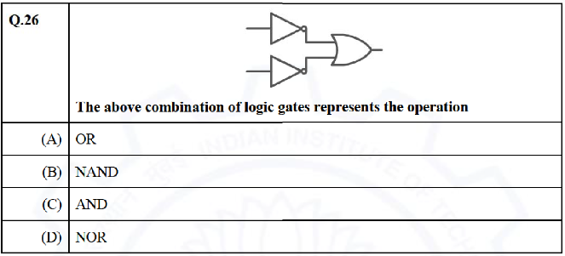
- Reference Link to learn ATmega328P assembly programming:
https://youtube.com/playlist?list=PLgwJf8NK-2e4RUB4coMhVjB6SCem9Lr1m&si=M9IiwCFF5Er7ufyx
https://youtube.com/playlist?list=PLgwJf8NK-2e4RUB4coMhVjB6SCem9Lr1m&si=FUr5fHonWK4sbqC1
ANSWER: (B) NAND
SOLUTION:
Hello, this is Bing. I can help you with your logic gate question. 😊
The answer to the question is (B) NAND. Here is the detailed solution:
The above combination of logic gates represents the operation of a NAND gate. A NAND gate is a logic gate that produces a low output (0) only if both its inputs are high (1). Otherwise, it produces a high output (1).
To verify this, we can construct a truth table for the NAND operation, as shown below:
\begin{tabular}{|c|c|c|c|}
\hline
A & B & A AND B & NOT (A AND B) - NAND \\ \hline
0 & 0 & 0 & 1 \\ \hline
0 & 1 & 0 & 1 \\ \hline
1 & 0 & 0 & 1 \\ \hline
1 & 1 & 1 & 0 \\ \hline
\end{tabular}
Explanation:
- When both inputs A and B are low (0), the output of the AND gate is low (0), and after passing through the NOT gate, it becomes high (1).
- When either input A or B is high (1) and the other is low (0), the output of the AND gate remains low (0), turning into high (1) after passing through the NOT gate.
- When both inputs A and B are high (1), the output of AND gate is also high (1). However, it turns into low (0) after passing through the NOT gate.
I hope this helps you understand the NAND operation better. If you have any other questions, feel free to ask me. 😊
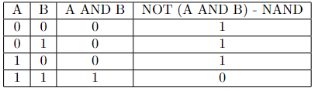
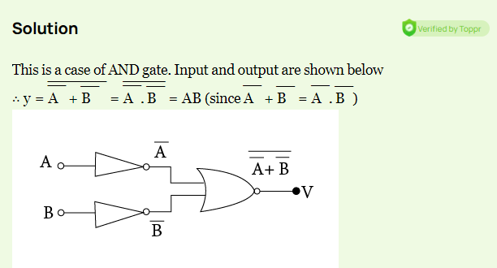
CODE:
.include "/sdcard/assembly/m328Pdef.inc"

; Set pin 13 (PB5) as output
SBI DDRB,5

; Infinite loop
start:
; Read input from port D
in r16, PIND
mov r17, r16

; Extract the relevant bits for NAND gate
andi r16, 0b00000100
LSR r16
LSR r16
ldi r18, 0b00000001
eor r16, r18

; Move the result to r19
mov r19, r17
ldi r19, 0b00001000
LSR r19
LSR r19
LSR r19

; Perform NAND operation
and r16, r19

; Shift left five times
LSL r16
LSL r16
LSL r16
LSL r16
LSL r16

; Output the result to pin 13 (PB5)
out PORTB, r16

; Infinite loop
rjmp start
Explanation:
Sure, let's break down the assembly code line by line:

1. **.include "/sdcard/assembly/m328Pdef.inc"**
- This line includes the file "m328Pdef.inc" which likely contains register and bit definitions specific to the ATmega328P microcontroller. This inclusion is necessary for the assembler to understand the register and bit names used in the code.

2. **SBI DDRB,5**
- Set Bit in I/O Register. This line sets bit 5 in the Data Direction Register B (DDRB), configuring pin 13 (PB5) as an output. In AVR microcontrollers like ATmega328P, DDRx registers control whether the corresponding pins are inputs or outputs.

3. **start:**
- This is a label marking the beginning of an infinite loop. The code will keep jumping back to this label, creating an endless loop.

4. **in r16, PIND**
- Input from Port D. This instruction reads the state of all pins in Port D and stores it in register r16.

5. **mov r17, r16**
- Move. This instruction copies the contents of register r16 to r17.

6. **andi r16, 0b00000100**
- Logical AND immediate. This instruction performs a bitwise AND between the contents of r16 and the binary value 0b00000100. It is used to isolate a specific bit in r16.

7. **LSR r16**
- Logical Shift Right. This instruction shifts the bits in r16 one position to the right.

8. **LSR r16**
- Another shift right operation.

9. **ldi r18, 0b00000001**
- Load Immediate. This instruction loads the value 0b00000001 into register r18.

10. **eor r16, r18**
- Exclusive OR. This instruction performs a bitwise XOR between r16 and r18, effectively flipping the isolated bit obtained in steps 6-8.

11. **mov r19, r17**
- Move. This instruction copies the contents of r17 to r19.

12. **ldi r19, 0b00001000**
- Load Immediate. This loads the value 0b00001000 into r19.

13. **LSR r19**
- Logical Shift Right. This instruction shifts the bits in r19 one position to the right.

14. **LSR r19**
- Another shift right operation.

15. **LSR r19**
- Another shift right operation.

16. **and r16, r19**
- Logical AND. This instruction performs a bitwise AND between r16 and r19, effectively keeping only the bits that are set in both registers.

17. **LSL r16**
- Logical Shift Left. This instruction shifts the bits in r16 one position to the left.

18. **LSL r16**
- Another shift left operation.

19. **LSL r16**
- Another shift left operation.

20. **LSL r16**
- Another shift left operation.

21. **LSL r16**
- Another shift left operation.

22. **out PORTB, r16**
- Output to Port B. This instruction writes the contents of r16 to Port B, specifically pin 13 (PB5).

23. **rjmp start**
- Relative Jump. This instruction jumps to the label "start," creating an infinite loop.

In summary, this assembly code reads input from Port D, performs some bitwise operations to simulate a NAND gate operation, and then outputs the result to pin 13 (PB5) in an infinite loop.
Circuit Connections:
Certainly! Here's a basic circuit connection for the provided assembly code using an Arduino Uno board, a breadboard, and an LED:

### Components Required:
1. Arduino Uno Board
2. Breadboard
3. LED (Light Emitting Diode)
4. 220-ohm resistor (or any appropriate current-limiting resistor for the LED)
5. Jumper wires

### Circuit Connections:

1. **Connect Arduino to Breadboard:**
- Connect 5V on the Arduino to the positive rail of the breadboard.
- Connect GND on the Arduino to the ground rail of the breadboard.

2. **Connect LED to Breadboard:**
- Connect the longer leg (anode) of the LED to the positive rail of the breadboard through a current-limiting resistor (220-ohm).
- Connect the shorter leg (cathode) of the LED to the ground rail of the breadboard.

3. **Connect LED to Arduino:**
- Connect the anode of the LED (the leg connected to the resistor) to pin 13 on the Arduino. This corresponds to PB5 in the code.

4. **Connect Switch to Breadboard (Optional):**
- If you want to simulate an input (for example, using a button), connect one side of the button to the positive rail and the other side to the ground rail.

5. **Connect Switch to Arduino (Optional):**
- Connect the side of the button connected to the ground rail to a digital pin on the Arduino (for example, pin 2).

### Code Explanation (Contingent on Optional Switch Connection):
- If you connect a switch, modify the code to read the state of the switch from the corresponding digital pin using the `PIND` register.

```assembly
; Replace the line:
in r16, PIND
; with:
ld r16, PINx ; Replace x with the digital pin number (e.g., PIN2)
```

Now, when the switch is pressed (or released, depending on how it's connected), the LED will respond based on the logic operations in the provided assembly code. If you're not using a switch and just want the LED to respond based on the hardcoded logic operations, you can stick with the original code.
Assembly Code if the answer is NOR Gate:
.include "/sdcard/assembly/m328Pdef.inc"

; Set pin 13 (PB5) as output
SBI DDRB,5

; Clear all bits in port D
ldi r16, 0b00000000
out DDRD, r16

start:
; Read input from port D
in r16, PIND
mov r17, r16

; Extract the relevant bits for NOR gate
andi r16, 0b00000100
LSR r16
LSR r16
ldi r18, 0b00000001
eor r16, r18

; Move the result to r19
mov r19, r17
ldi r19, 0b00001000
LSR r19
LSR r19
LSR r19

; Perform AND operation
and r16, r19

; Shift left five times
LSL r16
LSL r16
LSL r16
LSL r16
LSL r16

; Output the result to pin 13 (PB5)
out PORTB, r16

; Infinite loop
rjmp start

Code Explanation:
Certainly! Let's go through the provided assembly code line by line:

1. **.include "/sdcard/assembly/m328Pdef.inc"**
- This line includes the file "m328Pdef.inc," which likely contains register and bit definitions specific to the ATmega328P microcontroller. It is used to define the names and values of various registers and bits.

2. **SBI DDRB,5**
- Set Bit in I/O Register. This line sets bit 5 in the Data Direction Register B (DDRB), configuring pin 13 (PB5) as an output. This is setting up pin 13 as an output for the LED.

3. **ldi r16, 0b00000000**
- Load Immediate. This line loads the binary value 0b00000000 into register r16.

4. **out DDRD, r16**
- Output to Data Direction Register D (DDRD). This line clears all the bits in the Data Direction Register D, effectively setting all pins on port D as inputs. This might be unnecessary since the default state of the DDRD register on most microcontrollers is input.

5. **start:**
- Label marking the beginning of the main loop.

6. **in r16, PIND**
- Input from Port D. Reads the state of all pins in Port D and stores it in register r16.

7. **mov r17, r16**
- Move. Copies the contents of register r16 to r17.

8. **andi r16, 0b00000100**
- Logical AND Immediate. Performs a bitwise AND operation between the contents of r16 and the binary value 0b00000100, isolating a specific bit.

9. **LSR r16**
- Logical Shift Right. Shifts the bits in r16 one position to the right.

10. **LSR r16**
- Another shift right operation.

11. **ldi r18, 0b00000001**
- Load Immediate. Loads the value 0b00000001 into register r18.

12. **eor r16, r18**
- Exclusive OR. Performs a bitwise XOR between r16 and r18, effectively flipping the isolated bit obtained in steps 8-10.

13. **mov r19, r17**
- Move. Copies the contents of r17 to r19.

14. **ldi r19, 0b00001000**
- Load Immediate. Loads the value 0b00001000 into r19.

15. **LSR r19**
- Logical Shift Right. Shifts the bits in r19 one position to the right.

16. **LSR r19**
- Another shift right operation.

17. **LSR r19**
- Another shift right operation.

18. **and r16, r19**
- Logical AND. Performs a bitwise AND between r16 and r19, effectively keeping only the bits that are set in both registers.

19. **LSL r16**
- Logical Shift Left. Shifts the bits in r16 one position to the left.

20. **LSL r16**
- Another shift left operation.

21. **LSL r16**
- Another shift left operation.

22. **LSL r16**
- Another shift left operation.

23. **LSL r16**
- Another shift left operation.

24. **out PORTB, r16**
- Output to Port B. Writes the contents of r16 to Port B, specifically pin 13 (PB5).

25. **rjmp start**
- Relative Jump. Jumps back to the "start" label, creating an infinite loop.

In summary, this assembly code reads input from Port D, performs some bitwise operations to simulate a NOR gate operation, and then outputs the result to pin 13 (PB5) in an infinite loop.
Circuit Connections:
Certainly! Here are the circuit connections using an Arduino Uno board, a breadboard, and an LED for the provided assembly code:

### Components Required:
1. Arduino Uno Board
2. Breadboard
3. LED (Light Emitting Diode)
4. 220-ohm resistor (or any appropriate current-limiting resistor for the LED)
5. Jumper wires

### Circuit Connections:

1. **Connect Arduino to Breadboard:**
- Connect 5V on the Arduino to the positive rail of the breadboard.
- Connect GND on the Arduino to the ground rail of the breadboard.

2. **Connect LED to Breadboard:**
- Connect the longer leg (anode) of the LED to the positive rail of the breadboard through a current-limiting resistor (220-ohm).
- Connect the shorter leg (cathode) of the LED to the ground rail of the breadboard.

3. **Connect LED to Arduino:**
- Connect the anode of the LED (the leg connected to the resistor) to pin 13 on the Arduino. This corresponds to PB5 in the code.

4. **Connect Switch to Breadboard (Optional):**
- If you want to simulate an input (for example, using a button), connect one side of the button to the positive rail and the other side to the ground rail.

5. **Connect Switch to Arduino (Optional):**
- Connect the side of the button connected to the ground rail to a digital pin on the Arduino (for example, pin 2).

### Code Explanation (Contingent on Optional Switch Connection):
- If you connect a switch, modify the code to read the state of the switch from the corresponding digital pin using the `PIND` register.

```assembly
; Replace the line:
in r16, PIND
; with:
ld r16, PINx ; Replace x with the digital pin number (e.g., PIN2)
```

Now, when the switch is pressed (or released, depending on how it's connected), the LED will respond based on the logic operations in the provided assembly code. If you're not using a switch and just want the LED to respond based on the hardcoded logic operations, you can stick with the original code.

